# Resource Files Translation Utility

## External API and configuration

Resource (*.resx) Files Translation Utility provides a handy way to translate content of resource files from/to a bunch of languages using Yandex Translation API as a translation engine (see <https://translate.yandex.ua/developers>).

To be able to access the translation API, you should provide a bunch of settings in [appSettings] section of app.config file:

* YA_TRANSLATION_DIRECTIONS_URL_TMPLT – used to get possible translation directions from API. Currently the utility built to receive translation directions as a JSON.
* YA_TRANSLATION_URL_TMPLT – an URL template used to build translation requests.
* YA_TRANSLATION_API_KEY – authorization API key to get access to Yandex Translation API engine (for more details please visit <http://legal.yandex.ru/translate_api>)

## Usage

To achieve the translation results utility requires Internet connection. Please refer to Figure 1 for further usage explanations.

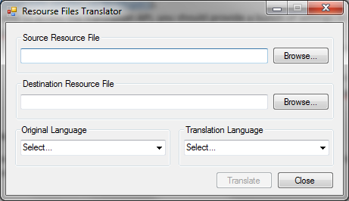

Figure 1 – Resource Files Translator utility main window

To get the translation you should pass through the following steps:

* 1. In [Source Resource File] section, you should populate file name you want to translate using Browse button. The utility currently supports only *.resx resource format.
  2. In [Destination Resource File] section, you should provide result file path. It will be the destination file for your translation. To point out a target folder, you could use the Browse button.
  3. Then you should point the language of your source file (there is no automatic language detection for source files implemented yet). It should be done by using the drop down list in [Original Language] section.
  4. In the section [Translation Language] you should opt for the translation language. Your source file will be translated into this language.
  5. Press Translate button and wait for the translation. The progress bar will illustrate translation progress (see Figure 2). You may cancel translation, if needed, by pressing Cancel Translation button.

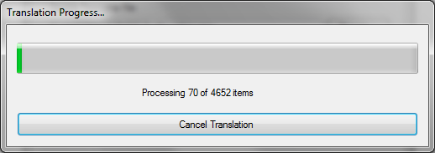

Figure 2 – Translation progress form

After the translation finished, you can get your translated file at destination specified in [Destination Resource File] section.